Report
On
Feature Engineering Project
At
Lachoo Memorial College of Science and Technology
Date: 07.11.2025


Submitted by: Ruchi Sankhla
Semester: III
MCA
Submitted to Dr Seema Loonker
Associate Professor
Project Title: Employee Attrition Prediction Dataset Using Feature Engineering
Source: Kaggle Dataset

Abstract

This project focuses on predicting employee attrition by preparing and refining a dataset using feature engineering techniques. The dataset “Employee Attrition Prediction” from Kaggle consists of 1,000 rows and 26 columns representing employee demographic information, job details, performance metrics, and work-related factors. The aim was to clean, integrate, transform, and reduce the dataset so it could be effectively used for predictive modeling. Feature engineering included handling missing values, treating noisy and duplicate data, encoding categorical variables, scaling numeric variables, discretization of continuous variables, and correlation analysis to reduce redundant features. The prepared dataset is now ready for machine learning algorithms like Logistic Regression, Decision Trees, and Random Forest for attrition prediction.

Introduction
Employee attrition is a major concern for organizations as it affects productivity, operational costs, and organizational knowledge retention. Predicting which employees are likely to leave allows HR departments to implement proactive strategies for retention. This project focuses on data preparation through feature engineering, which ensures that machine learning models can learn effectively and make accurate predictions.

Dataset Description

Source: Kaggle, “Employee Attrition Prediction”
Number of Rows: 1,000
Number of Columns: 26
Key Attributes:
Feature | Description
Employee_ID | Unique identifier for each employee
Age | Age of the employee
Gender | Gender of the employee
Marital_Status | Marital status of the employee (Single, Married, Divorced)
Department | Department the employee works in (e.g., HR, IT, Sales, Marketing)
Job_Role | Specific role within the department (e.g., Manager, Analyst)
Job_Level | Level in the organizational hierarchy
Monthly_Income | Monthly salary of the employee
Hourly_Rate | Rate per hour for hourly employees
Years_at_Company | Number of years the employee has been with the company
Years_in_Current_Role | Number of years the employee has been in their current role
Years_Since_Last_Promotion | Time since the employee’s last promotion
Work_Life_Balance | Rating of work-life balance
Job_Satisfaction | Rating of job satisfaction (1-5 scale)
Performance_Rating | Performance rating (1-5 scale)
Training_Hours_Last_Year | Number of training hours completed in the past year
Overtime | Whether the employee works overtime (Yes/No)
Project_Count | Number of projects managed by the employee
Average_Hours_Worked_Per_Week | Average working hours per week
Absenteeism | Number of days the employee was absent in the past year
Work_Environment_Satisfaction | Rating of work environment satisfaction
Relationship_with_Manager | Rating of the relationship with the manager
Job_Involvement | Rating of job involvement
Distance_From_Home | Distance from home to the workplace (in kilometers)
Number_of_Companies_Worked | Total number of companies the employee has worked for
Attrition | The target column (Yes/No) indicating whether the employee left the company

Tools Used

For this project, Python was used as the primary programming language due to its simplicity and extensive support for data analysis and machine learning tasks. The pandas library was employed for data cleaning, preprocessing, handling missing values, and integrating multiple datasets. NumPy was used for numerical computations and array manipulations, which helped in performing mathematical operations efficiently on the dataset.
For feature transformation and selection, scikit-learn was utilized. It provided tools for scaling, normalization, and encoding categorical variables. To visualize the data and understand feature relationships, matplotlib and seaborn libraries were used. Matplotlib helped in plotting graphs and histograms, while seaborn was used for enhanced visualizations like correlation heatmaps and feature distributions.
Finally, the project was developed and executed entirely in Jupyter Notebook, which allowed for interactive coding, testing, and visualizing results in a structured and organized manner.

Data Cleaning

This was the first and most crucial step to ensure data accuracy and reliability.
Tasks Performed:
- Loading the dataset:
The CSV file (employee_attrition_dataset.csv) was loaded into Jupyter Notebook using pandas.read_csv().
The dataset contained 1,000 rows and 26 columns, including demographic and job-related attributes.
- Checking for missing values:
Missing values were identified using df.isnull().sum().
For numerical features like Age or Monthly_Income, missing data was handled using median imputation.
For categorical columns like Gender or Department, the mode (most frequent value) was used for replacement.
- Detecting and treating noisy data:
Unrealistic entries were identified, such as out-of-range values (for example, Age = 150).
Such anomalies were replaced with more reasonable values, like the median of that column.
- Removing duplicates:
Duplicate employee entries (based on Employee_ID) were removed using the drop_duplicates() function to maintain unique records.
- Outlier detection and treatment:
Boxplots were used to detect extreme values, especially in Monthly_Income.
The Interquartile Range (IQR) method was applied to cap outliers within acceptable limits.

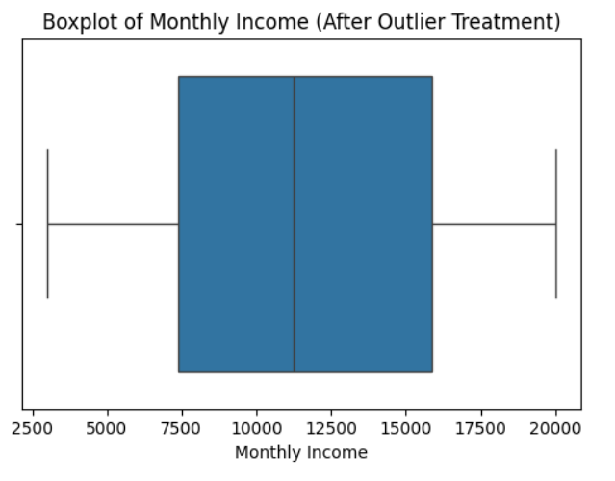
1.4: Data Visualization of Outlier Detection & Treatment

Data Integration

During the data integration phase, two CSV files were found in the dataset folder: employee_attrition_dataset.csv and employee_attrition_dataset_10000.csv.
Both files were loaded into separate dataframes and inspected using the head() function.
Upon analysis, it was observed that both datasets contained identical columns, structure, and values. Therefore, only one dataset (employee_attrition_dataset.csv) was used for further feature engineering tasks to avoid redundancy.
Tasks Performed:
- Standardizing column names:
All column names were converted to lowercase and spaces were replaced with underscores for uniformity.
Example: Monthly Income → monthly_income, Job Level → job_level.
- Checking for redundant identifiers:
Duplicate identifiers like emp_id or similar naming patterns were checked and unified into one column, employee_id.
- Consistency checks:
Verified that categorical entries were consistent.
For example, j.sharma and Jyoti Sharma were checked for mismatch possibilities (though none found). And probably this is not applicable on the dataset which is being used in this project.
- Unit consistency:
Confirmed that all salary values were in INR; hence no currency conversion was needed.
- Redundancy removal:
Checked for repeated or duplicate data columns — none found in this dataset.

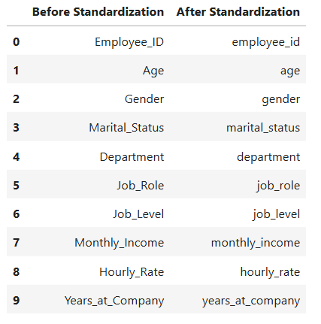
2.1 Data Visualization of Data Integration

Data Transformation

This step prepared the dataset for model training by converting categorical variables to numeric, scaling numerical data, and addressing skewness.
Tasks Performed:
- Encoding categorical data:
  - Label Encoding was used for binary features such as Gender, Overtime, and Attrition.
  - One-Hot Encoding was applied for multi-class columns like Department, Job_Role, and Marital_Status.
- Normalization and Standardization:
The dataset was scaled using Min-Max Normalization so that all numeric values ranged between 0 and 1.
This prevents features with large numeric ranges (like income) from dominating smaller-scale features.
- Log Transformation:
To handle right-skewed distributions (like Monthly_Income and Distance_From_Home), the natural log transformation (np.log1p()) was applied, making data more normally distributed.
- Discretization (Binning):
The continuous feature Monthly_Income was discretized into Low, Medium, and High salary groups using pd.qcut().
This helped create clearer patterns for categorical interpretation.
- Concept Hierarchy (Explained):
Although the dataset didn’t include location attributes, the concept of creating hierarchical data (e.g., City → State → Country) was discussed and demonstrated through example code.
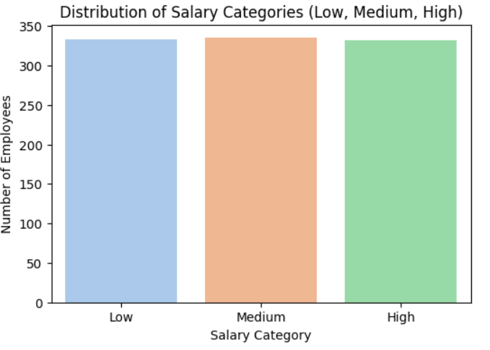

3.4: Data Visualization Discretization (Binning)

Data Reduction

After transformation, the dataset was refined further to eliminate unnecessary or redundant features, reducing complexity without losing information.
Tasks Performed:
- Removing unnecessary attributes:
The Employee_ID column was dropped as it serves only as an identifier and has no predictive power.
- Dimensionality reduction (Feature subset selection):
A correlation heatmap was created using Seaborn to visualize relationships between numeric features.
Highly correlated features (correlation > 0.9) were examined; one of each correlated pair was dropped to prevent multicollinearity.
- Correlation analysis:
It was found that Monthly_Income and Job_Level were somewhat correlated, but not enough to require removal (below threshold).
- Constant column check:
Any column with the same value across all rows (e.g., EmployeeCount) was checked — none were found.
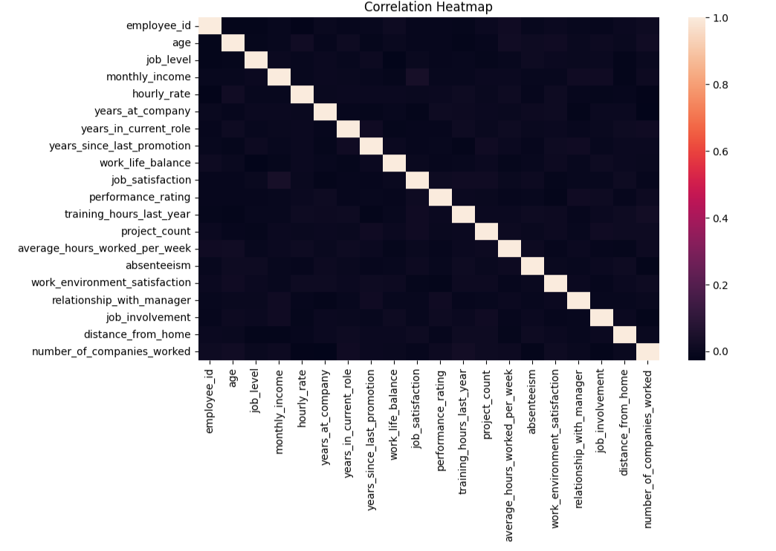
- Final dataset verification:
The resulting dataframe was confirmed to have only relevant, independent, and informative features for model training.
2.5: Remove Redundant / Highly Correlate Columns

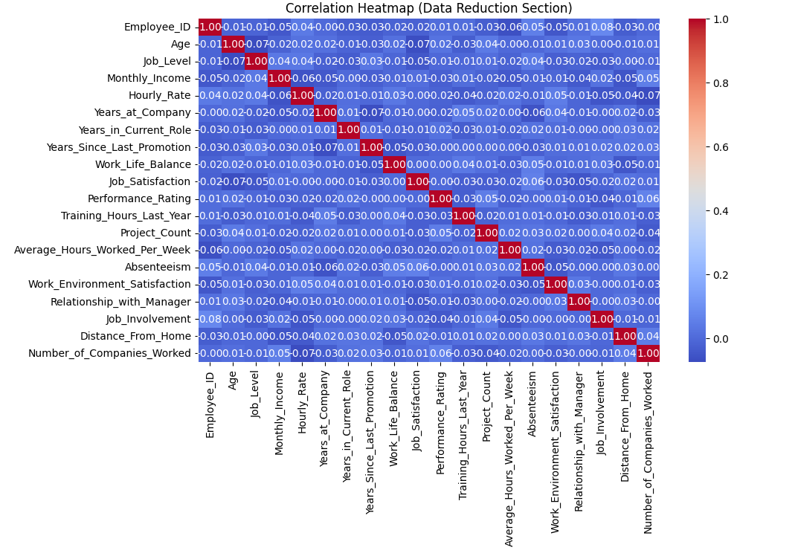
2.5: Data Visualization of Data Reduction

Outcome of the Methodology

After completing all these steps, the dataset achieved:
- 0 missing values
- No duplicates or irrelevant attributes
- Standardized column names
- Encoded categorical features
- Normalized numeric features
- Balanced and reduced feature set
This clean, well-structured dataset is now ready for machine learning model building and evaluation.

References

- Dataset Source:
Kaggle, Employee Attrition Prediction Dataset,
Available at: https://www.kaggle.com/datasets/ziya07/employee-attrition-prediction-dataset
(Accessed on: 04.11.2025)
- Python Libraries Used:
  - Pandas – Data manipulation and analysis.
  - NumPy – Numerical operations and handling arrays.
  - Matplotlib – Visualization and plotting library.
  - Seaborn – Statistical data visualization.
  - Scikit-learn (sklearn) – Preprocessing, encoding, scaling, and feature selection.
- Development Environment:
  - Jupyter Notebook – Interactive environment for data analysis and visualization.
  - Python 3.11 – Programming language used for implementation.
- Learning Resources / Documentation:
  - Python Official Documentation: https://docs.python.org/3/
  - Pandas Documentation: https://pandas.pydata.org/docs/
  - Scikit-learn User Guide: https://scikit-learn.org/stable/user_guide.html
- Conceptual References (Theory Concepts):
  - Han, Jiawei & Kamber, Micheline. Data Mining: Concepts and Techniques, 3rd Edition.
  - Online Article: “Feature Engineering in Machine Learning” – Towards Data Science, Medium.com.

